Shabbos Stories for
Parshas Nasso 5781
Volume 13, Issue 39 11 Sivan/May 22, 2021
Printed L’illuy nishmas Nechama bas R’ Noach, a”h

For a free subscription, please forward your request to keren18@juno.com
Past stories can be found on the website ShabbosStories.com

The Amazing Value
Of a Loaf of Bread
By Rabbi Dovid Goldwasser

The Torah (Devarim 21) tells us that when a corpse is found between two cities, the elders of the nearest city must declare their innocence vis-à-vis his death. The Talmud (Sotah 45b) elaborates that they affirm that they didn’t send him from their city without food and drink.
R’ Yisroel Salanter, founder of the mussar movement, asks: What connection is there between their assertion and the person’s murder? Would escorting him and giving him provisions have prevented his murder?
R’ Yisroel Salanter answers that self-confidence and hope empower an individual and make him feel worthwhile. Without it, a person despairs and becomes resigned to his fate. He becomes dispirited and disconsolate, feels alone, and loses his impulse for self-preservation such that death seems a worthwhile option.
On the other hand, when a person escorts a stranger and gives him provisions, he demonstrates to him that someone cares about him. The individual is then invigorated to defend himself if he is accosted, and his potential murderer might back off as a result.

Three Gifts of the Great Chassidic Master
The great chassidic master R’ Moshe Leib of Sassov was a disciple of R’ Shmelke of Nikolsburg for seven years. When R’ Moshe Leib departed, R’ Shmelke gave him provisions for the way, which included a loaf of bread, a gold coin, and a white coat.
On the road, R’ Moshe Leib heard loud bitter crying and set out to discover its source. He soon discovered a Jew who had been incarcerated by the local poritz (feudal landowner) because he didn’t have money to pay his rent. To boost his spirits, R’ Moshe Leib gave handed him his loaf of bread through the barred window of the prison. He then braced himself and headed to the poritz to try to secure the Jew’s release.
The irate poritz protested that the Jew owed him a few hundred zlotys. R’ Moshe Leib offered the valuable gold coin in his possession to cover some of the rent. But the poritz refused to accept it and had R’ Moshe Leib removed from his presence. The Sassover, renowned for his ahavas Yisroel, was set to continue his journey but found it difficult to abandon his brother, so he returned to the poritz to plead on behalf of the Jew.

Enraged to See Moshe Leib Again
Enraged to see him again, the poritz ordered that R’ Moshe Leib be thrown to the dogs. As he was being led to his execution, R’ Leib recalled the white coat R’ Shmelke had given him and put it on. As soon as he did, the dogs, which had been rushing towards him, retreated and returned to their kennels.
When the poritz witnessed this scene, he realized that R’ Moshe Leib was a holy man, became overcome with fright, and quickly ordered the release of the poor Jew from prison.
How potent is tzeidah l’derech, reviving an individual in many different ways.

Reprinted from the April 29, 2021 edition of The Jewish Press.
Story #1221
A Son for a Son
From the desk of Yerachmiel Tilles
editor@ascentofsafed.com

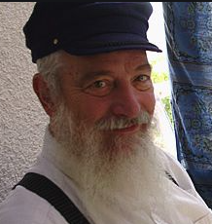
Yerachmiel Tilles

[Editor’s note: This story is based on Story #596 in this series from 12 years ago, but the writing has been extensively revised and, more importantly, much detail has been added (see Source note at end) names instead of pseudonyms, etc.]
In the early 2000’s, Gadi Rimon, an Israeli Defense Force soldier stationed outside of Ramallah, was shot by an Arab terrorist. It happened very early in the morning, and no one else was awake to hear it. Gadi passed out and was bleeding steadily, his life heading toward a silent end.

Another Soldier Did Hear the Shot
However, another soldier, Shlomo Bergman, who was stationed nearby, heard the shot and went to investigate. He found a fellow Israeli soldier bleeding to death. He tried the best he could to stop the bleeding and called for help. While waiting, he kept applying pressure to the wound--literally holding Gadi's life in his hands.
Gadi was taken to the nearest Israeli hospital where he underwent emergency surgery. Gadi's parents were notified and they rushed to the hospital. Imagine the fear of the parents who were only told, "Your son has been injured and is in the hospital undergoing surgery."
The Doctor Talks to the Parents
When they arrived the doctor, Rafi Beket, told them that Gadi was shot and had needed many units of blood, but will recover and be alright. However, had it not been for the immediate actions of the other soldier, their son would have bled to death.
It was a miracle that the other soldier heard what no one else heard, and managed to locate Gadi as quickly as he did. The parents wanted to thank that soldier, but he had just left the hospital after hearing that the soldier he helped would survive.

Unable to Discover the Son’s Savior
While recuperating at home, Gadi and his parents called the army to find out the name of the other soldier so they could thank him personally. Unfortunately, that soldier's name was not recorded and although they tried other paths of enquiry, they were unable to track down who that other soldier was.
Gadi's mother, Tamar Rimon, knew that the important thing of course is that Gadi is well, yet she could not help feeling that as long as she couldn’t meet and thank the solider who bravely saved her son’s life--the entire frightening episode would not be fully over. Not being able to express gratitude to the soldier continued to give her an empty feeling.
But then she had an idea.

A Grocery Store in Ashdod
The couple owned a grocery store in Ashdod, so they decided to put up a sign in the store, describing what happened, figuring that Israel is a small country and eventually they might find out who the mystery soldier was.
Nearly a year passed with no response. Finally, one morning about a year later, a woman customer from out of town noticed, upon exiting, the sign hanging by the door of the store. Anat Bergman recalled how happy her son Shlomo was when he came home one Friday night and told them how he heard a shot and was able to save another soldier’s life. She went back and told her son’s story to Tamar Rimon, who was behind the counter that morning. The two stories matched and the two women fell into each other’s arms.
After a few emotional minutes, they decided to try to reach their sons on cell phones and see if they could meet at the store. Fortunately it turned out that both the young men and even the fathers were able to all meet there that afternoon.
The families gathered for an emotional rendezvous. The soldiers recounted army experiences and finally after all this time Tamar Rimon could stand up and thank Shlomo Bergman for saving her son Gadi’s life. Or, as she put it, “You saved my world”. She looked forward to feeling completion after all this time by thanking the soldier. Little did she know that the story was hardly complete.

A Private Talk Amongst Women
After the tearful thank you, Anat privately asked Tamar to speak with her outside. The two women went out alone, whereupon Shlomo’s mother startled Gadi’s mother by asking her, “Look at me – don’t you remember me?”
“No, I’m sorry. Did we meet before? When? Where?”
"Yes, we did,” Anat replied. “You see there is a particular reason I came into your store today. I used to live here, and this time although I was just passing by, I wanted to give you my business, even though I was only buying a few things. I just can’t believe you are the mother of the boy whose life my son saved.”
“What are you talking about?” Gadi’s mother exclaimed.
The other woman answered, “Twenty-two years ago I used to live around here and came all the time to buy milk and bread. One day you noticed that I looked really down and you were very nice and asked me why I seemed so down and I confided in you. I said that I was going through a very difficult time, and on top of that I was pregnant and planning on having an abortion.
“As soon as I said abortion you called your husband over and the two of you seemed to forget about your own store and business. You just sat down and patiently listened to me. I still remember clearly what you said.

Convinced to Have the Baby
“You told me that it is true that I was going through a hard time but sometimes the good things in life come through difficulty, and the best things come through the biggest difficulties. You spoke of the joy of being a mother and that the most beautiful word to hear in the Hebrew language is “Ima” (Mommy) when spoken by one’s child. You both spoke and spoke until I was convinced that I really should have this baby. So you see, G-d paid you back!”
Tamar’s eyes opened wide. Anat continued.
“I had a boy twenty-one years ago that you saved by telling me to think twice before doing the abortion.” With happy tears she declared, "My beloved Shlomo wouldn’t have been alive if not for you. And lo, he was the one who grew up to save your precious Gadi’s life!"
~~~~~~~~~~~~~~~~
Adapted by Yerachmiel Tilles from friendsofefrat.org , * the website of a wonderful organization, EFRAT, that dedicatedly (and non-violently!) works to prevent abortions by Jewish mothers in Israel, through counseling and financial incentives. Updated this week with the actual names and a few more facts from a clip sent to me of a television news report at the time of the episode,
* This site is no longer functional. The new, much more professional, site, has 16 very short but worthy stories, but no longer includes the above long one.
Connection -- Weekly reading, which includes a detailed section on the relative evaluations of Jewish lives (young vs. old, etc.) when a pledge is made to the Holy Temple do donate someone’s economic worth.

APPENDIX
"Heavenly supervision strikes again!
I just received this striking example with the same theme as the above story.

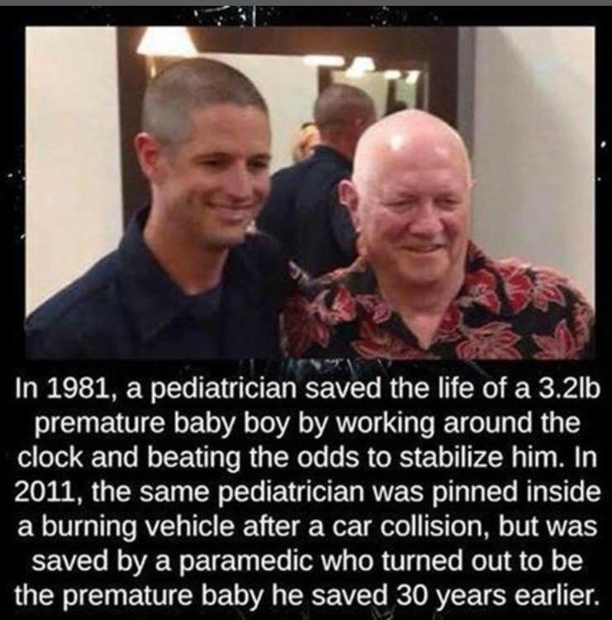
Reprinted from the Parshat Behar-Bechukosai 5781 email of KabbalaOnline.org, a project of Ascent of Safed.

The Money in the Barrel
By Hillel Baron

There was once a young man living in Prague who struggled to make a living. He eventually convinced his wife that he needed to leave home to seek his fortune elsewhere. He explained that after he made a nice sum of money, he would return home to establish a business.
The young man traveled to another town, and kept in touch with his family. But after a while, he stopped communicating. Eventually, his family began to give up on ever seeing him again—they assumed something must have happened to him.

The Wine Merchant
A wine merchant from Prague, who traveled to the countryside every year to purchase kosher wine at wholesale prices, happened to travel to the place where the young man was living. Arriving at the local winemaker’s shop, he encountered the young man himself. He invited him to sit down and talk, and convinced him to come back home. After the young man agreed, the merchant offered him a ride in his wagon, which by then was filled with the wine he had purchased.
The young man had a bundle of money he had amassed throughout his years away. He began to worry that the merchant's workers may notice and try to steal it, so he hung the bundle from his neck with the bulge under the back of his shirt. After a while, however, he grew worried about this arrangement too. So when no one was looking, he broke the seal on one of the wine barrels, lowered his bundle into it, and then closed the barrel. Finally, he could relax.
When they arrived in Prague, the businessman said to the young man: “Before I drive you home, let me first drop off the wine at my storage facility.” As the barrels were unloaded, the young man tried to keep track of the barrel with his money so that he could return later to retrieve it.

Watching the Barrels Being Unloaded
But as he watched the barrels being unloaded, he saw that every single one of them was sealed. He couldn’t locate the barrel in which he had hidden his money. So he approached the businessman and told him what he had done. “Where is my money now?” he asked. “I see that all the barrels are now sealed.” The businessman became visibly agitated, and said, “How dare you suspect me. I’m sorry but I don’t know where your money is.”
The young man was understandably devastated. He had worked for years to earn this money, and it was the reason he had been separated from his family for all this time. He went off to the chief rabbi of the city, Rabbi Yechezkel Landau (1713-1793), known as the “Noda B’Yehudah,” and asked for his help. The rabbi agreed to summon the businessman and question him.
Immediately after the questioning began, the businessman again became enraged, and started shouting, “How could this be? I did this man a favor! He should thank me for what I did for him —now he’s turning around and accusing me of theft?!”

Aware of the Talmudic Passage
The Noda B’ Yehudah was aware of the Talmudic¹ passage which states that there are three ways through which one’s true character can be known: By the cup (how one acts when they have been drinking), the pocket (how one spends their money) and by anger (how they react to adversity and confrontation).
Realizing that the businessman’s quickness to anger revealed strong feelings of guilt, he advised: “If it was not you who took the money and resealed the barrel, then it must have been one of your non-Jewish workers. If a gentile touches unsealed wine, the wine is no longer kosher. Since we do not know which barrel it was, I must reluctantly rule that all of your wine is non-kosher, and may not be sold to Jews.”
Realizing that he stood to lose many more times than the sum he had stolen, the merchant admitted his guilt. “It wasn’t the gentiles!” he cried. “I myself have taken the money from this man. It is I who am guilty.”
The rabbi instructed him to return the money and beg the young man for forgiveness. He also told him how to do teshuvah² for what he had done. From then on, he became a righteous man.
Does it ever happen that after we help someone, we are tempted to be dishonest with that person, “justified” by the fact that this person “owes us”? Does it happen that we are dishonest once, and it leads to even greater dishonesty which gets us into further trouble? How would we help a person realize that they must do teshuvah?
(Source: Sefer Hamasiyot, p. 171)

FOOTNOTES
1. Eruvin, 65a.
2. (lit. “return”); repentance, return to a Jew’s true essence.

Reprinted from the Parshat Behar-Bechukosai 5781 email of Chabad.Org Magazine.
“Like A Malach” – The
Post That Moved
Thousands of Israelis

Moshe Natan Neta, z'l, 14, and Yehoshua, z'l, 9, Englard.

Yakir Asaraf, a secular Israeli, who like many others was shocked by the immensity of the Meron tragedy, decided that he had to do something to share in the families’ pain, and he and a friend went to pay a shiva call to the Englard family of Jerusalem, who lost their two sons, Moshe Natan Neta, z’l, 14, and Yehoshua, z’l, 9.
He wrote a Facebook post about his experience, which quickly went viral and moved thousands of Israelis.
“It could be that I just experienced one of the most significant moments of my life,” Asaraf wrote. “I just left the shiva of the Englard family, who lost their two sons at Meron. And my heart is simply bursting with mixed emotions, my eyes are filled with sad tears, but my heart is full of simcha.”
“When my friend Maor and I, dressed in jeans and T-shirts, entered their home, we really stood out in the Chareidi crowd. Some people looked up and two wonderful Chareidim quickly got up and let us sit, mamash opposite Menachem Mendel, the father who lost his two sons just days ago.”
“The father noticed us and quickly stopped speaking in Yiddish with the other menachamim and turned to me and Maor in Hebrew.”

Yakir Asaraf (Facebook profile)

“‘I’m happy you came,’ he said, and his eyes are wet with tears but his face is radiant. “When are we already zochech to meet together – you and I?’ he said.
“Maor and I looked at him with sparkling eyes as if he’s a malach talking to us.
“‘You should know that what’s happening here is the truth,” he said. ‘You and I are both pained by the great loss. We’re giving chizzuk to each other. It doesn’t matter if you’re chilonim (secular) or Chareidim – we’re Jews.”
“Everyone else in the room – in eerie silence – is quietly listening to Menachem Mendel talk to us.
“‘I want you to invite me to your simchos!'” I say.
“‘And I’ll invite you to my simchos!'” he responds.
“A few minutes of silence and he looks down and mumbles; ‘Mi K’Amcha Yisrael.’
After the tefillah, we approach him and before we had a chance to say words of comfort, he says, ‘Thank you for coming. You were mechazeik me.'”
“Maor and I leave the house, looking at each other, but unable to speak. We can’t process what just happened, and while I’m writing these words, I still can’t process it.
“This meeting represents the truth of our Am, the endless Ahavas HaChinum we have for each other, our shared pain, the tremendous emunah that continues to unite us.”
“I’ll end with a tefillah l’Yoshevi Ba’Meromim – for Ahavas Chinam between us, and for besuros tovos, and for all the families of the victims to be zochech to true nachas, and that I’m zocheh to be invited to the smachos of the wonderful Menachem Mendel.”

Reprinted from the May 5, 2021 website of Yeshiva World News.

Saved By the Enemy

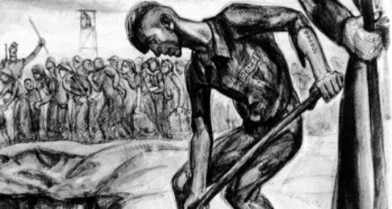

Moshe trudged through the deep snow, shivering in his rags and shuffling along as quickly as he could to avoid yet another beating from the Nazi guard. He and the other concentration camp inmates had already been savagely beaten earlier that morning before they were ordered out of the camp. Now, he marched along as best as he could, one of a double line of men who were ordered to build railroad tracks for their enemies.
Soon, they arrived at the unfinished tracks. Moshe wearily bent over his task, hammering and banging all day long as they laid new rails. The overseer watched his prisoners carefully, eager to spot the first sign of slacking or laziness that would allow him to unleash a fresh string of expletives and another beating.
Whenever the inmates completed a section of the track, a train was sent down the mountainside to test the efficiency of the newly-finished rails. Moshe and the others quaked at the thought of their tormentors finding fault in their work.
There came a time when Moshe felt that all his strength was gone. His arms trembled as he tried to lift up the heavy hammer. Feebly, he pounded at the track as the rails swam in front of his eyes.
Suddenly a shout rang out. "Everyone off the tracks! They're sending a train down!" All the inmates ran off the tracks to safety - except Moshe. Utterly exhausted, he simply collapsed right where he was, lying across the tracks as the train thundered down the mountainside.
Later, he find out how his life had been saved. The overseer had spotted Moshe lying on the track and pounced on him. "Lazy, dirty Jew!" the man bellowed. "Get up and get back to work!" When Moshe did not respond, the overseer exploded with rage and reached out a beefy hand to grab the unconscious Jew by his ragged shirt and lift him bodily off the tracks.
"How dare you disobey me?" he bellowed, shaking Moshe violently before tossing him to one side with disgust. Moments later, the train roared along the tracks, shaking the rails from side to side as it passed over the point where Moshe had been lying only moments earlier.
Years later, when Moshe emigrated to America, he related this story to Rav Aharon Kotler. R' Aharon smiled and noted, "If it is Hashem's will that one should live, then even a murderer can be the savior." (Visions of Greatness II by Rabbi Yosef Weiss, z”l)

Reprinted from the Parshat Behar Bechukotai 5781 email of Shabbat Shalom from Cyberspace (edited by Rabbi David Bibi.)

The Chossid’s Loud Prayers

A Stoliner chossid was once in a town for Shabbos. The Rabbi of the town hosted him for Shabbos, and in their lively conversation at the meal Friday night, the chossid informed the Rabbi, that his custom is to daven every word loud. The Rabbi warned him, that he must daven silently the entire time.
Wanting to keep the peace and avoid any confrontation, the chossid put all his efforts to daven silently. However, when a person is davening with feeling and emotion, how long can one remain silent. By the time, he came to Boruch She’umar, the people sitting next to him heard him and in Birchas krias Shema, the entire shul heard him. After davening, the Rov and the entire congregation congratulated him on such a heartfelt davening.
The chossid was perplexed, last night the Rov warned him not to daven loudly, and now the Rov is thanking him for doing so?

The Rabbi explained; “When you told me you plan on davening loud that was noise that I wanted to stop. But today when it burst forth from your heart, that was music to the ears, and that is what we enjoyed and thanked you for.”

Excerpted from the April 29, 2021email of The Weekly Story by Rabbi Sholom DovBer Avtzon.

The Gratitude of
Rav Elazar Shach

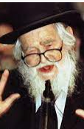

Rabbi Asher Bergman writes that in the beginning of Rav Elazar Shach’s married life, Rav Shach and his family rented an apartment in Yerushalayim from Rav Alter Shub. Although Rav Shach paid rent for his living quarters, he nonetheless felt gratitude towards the Shub family for giving this benefit to him. Rav Shach considered it his duty to treat the Shub family exceptionally well, even extending this treatment to the family’s children. Many years after Rav Shach moved to Bnei Brak, it happened that some of Rav Alter Shub’s grandchildren found themselves in Bnei Brak late one evening, without any means of transportation available for them to take them home to Yerushalayim.
Rav Shach was overjoyed at the opportunity to host them in his home for the night, as a way of expressing his gratitude to his ‘landlord’, which was how he referred to Rav Alter. Later, Rebbetzin Guttel Shach quietly told the guests that Rav Shach had been planning to go out somewhere that night, but because of the Mitzvah of Hachnasas Orchim and HaKaras HaTov that had come his way, he had stayed at home!

Reprinted from the Parshas Vayechi 5781 email of Torah U’Tefilah (compiled by Rabbi Yehuda Winzelberg.)

The Brocha of the Rebbe

Once, a man brought his ten-year-old son to visit Rav Aharon Karlin, zt”l. As they were sitting and talking, Rav Aharon asked for a bowl of apples to be brought in. Rav Aharon and his guests each took an apple, and with great Kavanah, Rav Aharon said the Brachah of Borei Pri HaEitz, and he began to eat.
The boy thought to himself, ‘What is the difference between me and the Rebbe? He eats apples, and I also eat apples. He says a Brachah, and so do I. Even I could be the Rebbe someday!’
Rav Aharon, almost as if he were aware of the boy’s thoughts, turned to the child and said, “You know, my son, there is a big difference between the two of us. When you wake up in the morning and look out the window, you can see that there is a beautiful apple tree in your yard. You can see the juicy, red apples growing on it and all you can think of is when you can eat those apples.
“You run to wash your hands, get dressed as quickly as possible, and run out to the apple tree. You quickly decide which apple is going to be for your breakfast, and you open your mouth for that first delicious bite. You almost take that bite of the apple until you remember, just in time, that you must say a Brachah before eating an apple. So, you say the Brachah in order to eat.”
The boy and his father listened, captivated to the words of the great Rebbe. Rav Aharon continued, “However, my son, when I wake up in the morning, it is different. When I look out the window, I also see a beautiful apple tree, and it makes me think about the wonder of Hashem’s creation. I contemplate how this apple tree began as a small seed in the ground, and how it slowly grew year by year until one day blossoms began to flower, and then apples appeared.
“I run to wash my hands before I quickly go outside to take a closer look at this amazing creation. In awe of Hashem and His creation, the apple tree, I want to say a Brachah on the apple tree and its fruits. I begin to say the Brachah of Borei Pri HaEitz, but then I remember, in order to say a Brachah, I need an apple. That’s the difference between us. You say a Brachah in order to eat, and I eat only so I am able to say a Brachah!”
The Karliner Rebbe taught that one should use food as an opportunity to grow in Ruchniyus and getting closer to Hashem, and not just to satisfy a craving!

Reprinted from the Parshas Vayechi 5781 email of Torah U’Tefilah (compiled by Rabbi Yehuda Winzelberg.

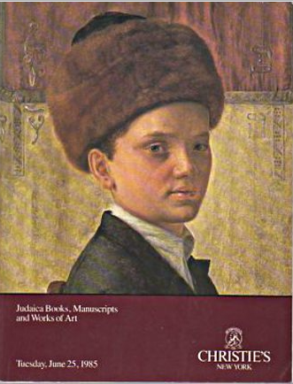
The catalogue cover of the June 25th 1985 Chrisites Judaica Auction.

